**Subject-Verb Agreement**

[**Subjects**](https://webapps.towson.edu/ows/nouns.htm#Subject) and [**verbs**](https://webapps.towson.edu/ows/verbs.htm) must AGREE with one another in **number** (singular or plural).  Thus, if a subject is singular, its verb must also be singular; if a subject is plural, its verb must also be plural. Subject verb agreement deals with the idea of this peaceful correlation between the subject and the verb. The verb should be used according to the subject of the sentence. It is one of the most common mistakes found in writing.

Some rules related to subject-verb agreement:

**1.  A**[**phrase**](https://webapps.towson.edu/ows/sentelmt.htm#Phrases)**or**[**clause**](https://webapps.towson.edu/ows/sentelmt.htm#Clauses)**between subject and verb** does not change the number of the subject.

                Examples:

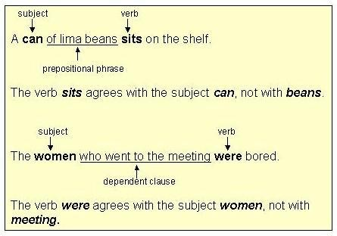

          As you can see in the first sentence, the subject is **Can.** We should not be fooled by the phrase ‘of lima beans’. It only is only giving an idea about the can. So, the verb should follow the word **can**.

**2.**[**Indefinite pronouns**](https://webapps.towson.edu/ows/pronouns.htm#indefinite%20pronouns)**as subjects**

* **Singular indefinite pronoun subjects** take singular verbs.

https://webapps.towson.edu/ows/singirregpron.jpg

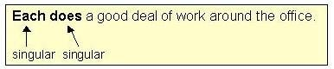

* **Plural indefinite pronoun subjects** take plural verbs.

   PLURAL:*several, few, both, many*

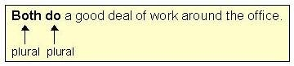

* Some **indefinite pronouns**may be either**singular or plural**: with *uncountable*, use singular; with *countable*, use plural.

   EITHER SINGULAR OR PLURAL:  *some, any, none, all, most*

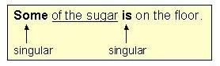

                Sugar is *uncountable*; therefore, the sentence has a singular verb.

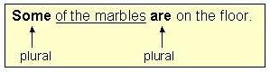

                Marbles are *countable*; therefore, the sentence has a plural verb.

**3.**[**Compound subjects**](https://webapps.towson.edu/ows/sentences.htm#SIMPLE%20SENTENCE)**joined by *and*** are always plural.

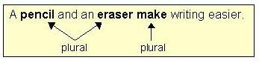

**4.**  With **compound subjects joined by *or/nor***, the verb agrees with the subject nearer to it.

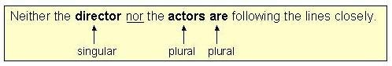

          In the above example, the plural verb ***are*** agrees with the nearer subject ***actors***.

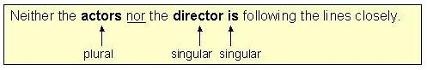

            In this example, the singular verb***is***agrees with the nearer subject ***director***.

**5.  Inverted Subjects**must agree with the verb.

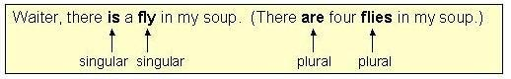

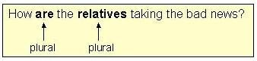

**\*Inverted Subject:** In English, the usual order of words in a sentence is subject + verb + object. Sometimes certain adverbs come at the beginning of the sentence. This order is then inverted and the verb comes before the subject.

**6.  Collective Nouns** (*group, jury, crowd, team, etc.)*may be singular or plural, depending on meaning.

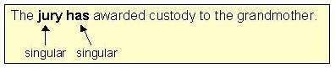

            In this example, the jury is acting as one unit; therefore, the verb is singular.

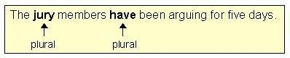

            In this example, the jury members are acting as twelve individuals; therefore, the verb is plural.

**7.  Titles of single entities** (*books, organizations, countries,*etc*.)* are always **singular**.

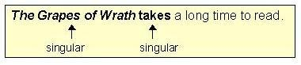

**8.  Plural form subjects**

* **Plural form subjects with a singular meaning** take a singular verb.(e.g. *news, measles, mumps, physics, etc.)*

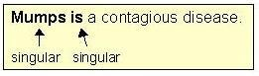

* **Plural form subjects with singular or plural meaning**take a singular or plural verb, depending on meaning.(e.g. *politics, economics,*etc.)

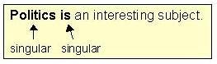

    In this example, politics is a single topic; therefore, the sentence has a singular verb.

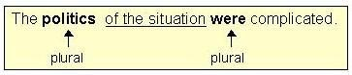

    In this example, politics refers to the many aspects of the situation; therefore, the sentence has a plural verb.

* **Plural form subjects with a plural meaning** take a plural verb.(e.g.  *scissors, trousers*)

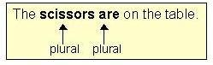

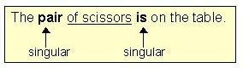

**Note:** In this example, the subject of the sentence is *pair*; therefore, the verb must agree with it.  (Because *scissors* is the object of the [preposition](https://webapps.towson.edu/ows/prepositions.htm), *scissors*[does not affect](https://webapps.towson.edu/ows/sub-verb.htm#rule1) the number of the verb.)

**9.  With subject and subjective complement of different number**, the verb always agrees with the subject.

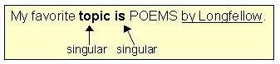

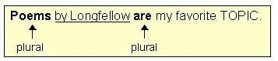

**\*Subject Complement**

A subject complement is a word or phrase that follows a linking verb and identifies or describes the subject.

*Ben is a policeman.*

(The linking verb is is (i.e., the verb to be). The subject complement identifies the subject Ben. It is a noun.)

*He will be fine.*

(The linking verb is will be (i.e., the verb to be). The subject complement describes the subject He. It is an adjective.)

A subject complement is either an adjective, a noun, or a pronoun.

**10-A**. **With *one of those ________ who***, use a plural verb.

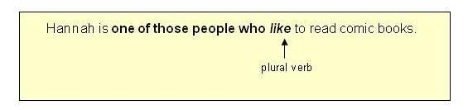

 The above example implies that others besides Hannah like to read comic books.  Therefore, the plural verb is the correct form to use.

**10-B.**  **With** ***the only one of those ________who,*** use a singular verb.

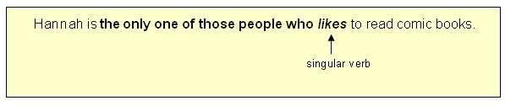

     The above example implies that no one else except for Hannah likes to read comic books.  Therefore, the singular verb is the correct for to use.

11-A.  **With *the number of _______,*** use a singular verb.  
              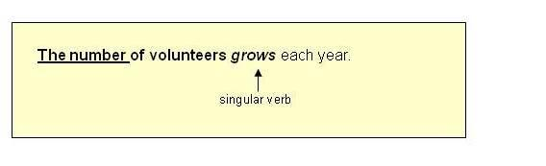

11-B.  **With *a number of _______*,** use a plural verb.  
              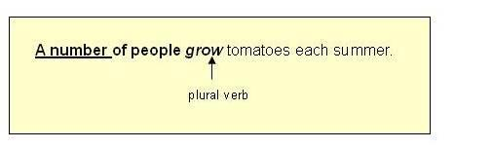

12.  **With** ***every ______*** and ***many a ________***, use a singular verb.

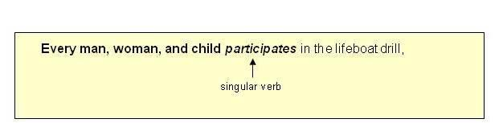

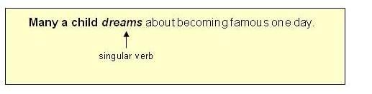

**Source:** [**https://webapps.towson.edu/ows/sub-verb.htm**](https://webapps.towson.edu/ows/sub-verb.htm)

**For further study:** [**http://guidetogrammar.org/grammar/sv_agr.htm**](http://guidetogrammar.org/grammar/sv_agr.htm)

**Exercises: (Practice them!)**

[**https://owl.purdue.edu/owl_exercises/sentence_structure/subject_verb_agreement/subject_verb_agreement_exercise.html**](https://owl.purdue.edu/owl_exercises/sentence_structure/subject_verb_agreement/subject_verb_agreement_exercise.html)

[**http://a4esl.org/q/j/kf/mc-svae.html**](http://a4esl.org/q/j/kf/mc-svae.html)

[**http://a4esl.org/q/h/vm/svagr.html**](http://a4esl.org/q/h/vm/svagr.html)

[**http://a4esl.org/q/h/9901/cw-svagreement.html**](http://a4esl.org/q/h/9901/cw-svagreement.html)

[**http://a4esl.org/q/j/kf/mc-svad.html**](http://a4esl.org/q/j/kf/mc-svad.html)

**Appropriate Preposition:**

Read the following list.

<https://www.smart-words.org/linking-words/list-of-prepositions.pdf>

**Commonly Used Phrases and Idioms:**

Go through the following list:

<https://www.fluentu.com/blog/english/english-idioms-6/>